R. Reports Menu: 2. Chart of Accounts

Table of Contents
Chart of Accounts 3
The “Output” tab 3
The “Accounts” tab 4
The “More Accounts” tab 6

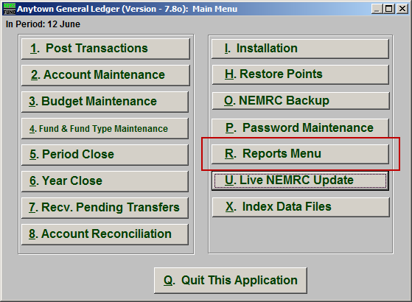
Click on “R. Reports Menu” from the Main Menu and the following window will appear:

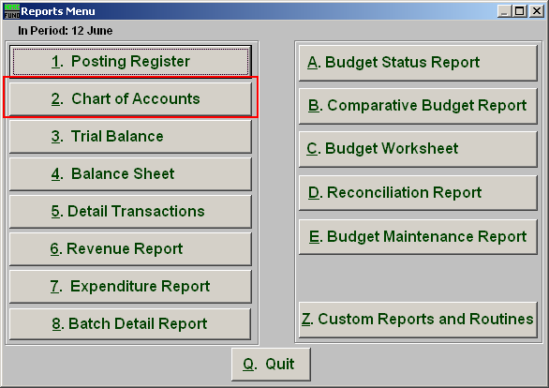
Click on “2. Chart of Accounts” from the Reports Menu and the following window will appear:

Chart of Accounts

The “Output” tab

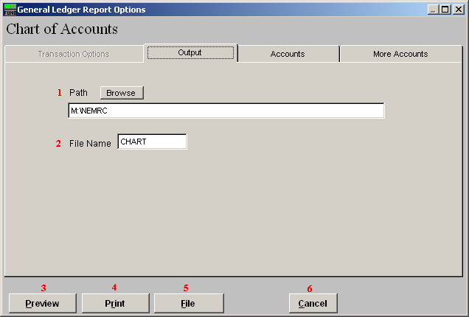
- Path: Type in the location of the folder you wish to save this report in when you export. You may click “Browse” to locate the folder.

- File Name: Type in the name that this report will be saved as.

- Preview: Click this button to preview. Refer to GENERAL PREVIEW for more information.

- Print: Click this button to print. Refer to GENERAL PRINTING for more information.

- File: Click this button to save on this computer. Refer to GENERAL FILE for more information.

- Cancel: Click “Cancel” to cancel and return to the previous screen.

The “Accounts” tab

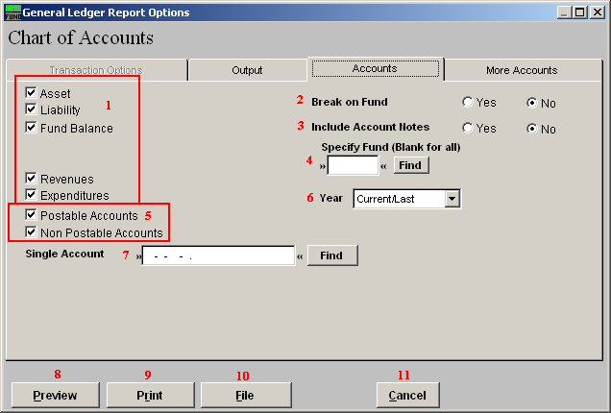
- Account types: You can select some or all account types to report detail postings for. The types available are dependant on the design of your chart of accounts.

- Break on Fund: Select “Yes” if you want to list each fund separately.

- Include Account Notes: Choose “Yes” to have this report include Account Notes that can be entered in Account Maintenance.

- Specify Fund: Type the Fund number you would like the report be for OR leave blank for all.

- Postable Accounts, Non Postable Accounts: Select the option to include accounts that are presently active (postable) and/or inactive (non-postable). You must select at least one of these two choices.

- Year: Select a specific year from the drop down list if you are looking for a listing prior to the current chart of accounts.

- Single Account: Enter the specific account you are trying to report if desired. When selecting a single account you will get the current and last year balances by period.

- Preview: Click this button to preview. Refer to GENERAL PREVIEW for more information.

- Print: Click this button to print. Refer to GENERAL PRINTING for more information.

- File: Click this button to save on this computer. Refer to GENERAL FILE for more information.

- Cancel: Click “Cancel” to cancel and return to the previous screen.

The “More Accounts” tab

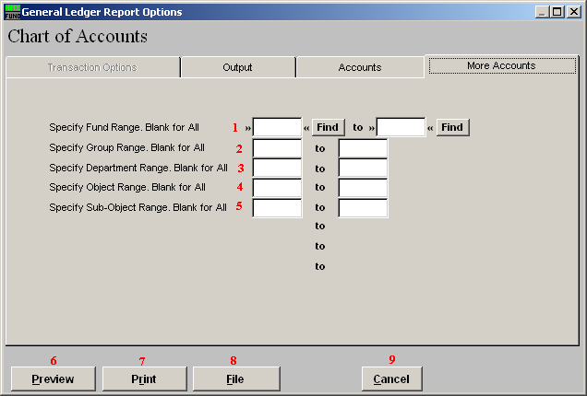
- Specify Fund Range: This option appears for all charts of accounts. Type in a beginning and ending fund number range to further restrict the reporting if desired. Items 2 through 5 will vary according to the design and descriptions for your chart of accounts definitions.

- Specify Group Range: Enter a beginning and ending value range to further restrict the reporting if desired.

- Specify Department Range: Enter a beginning and ending value range to further restrict the reporting if desired.

- Specify Object Range: Enter a beginning and ending value range to further restrict the reporting if desired.

- Specify Sub-Object Range: Enter a beginning and ending value range to further restrict the reporting if desired.

- Preview: Click this button to preview. Refer to GENERAL PREVIEW for more information.

- Print: Click this button to print. Refer to GENERAL PRINTING for more information.

- File: Click this button to save on this computer. Refer to GENERAL FILE for more information.

- Cancel: Click “Cancel” to cancel and return to the previous screen.

